

**Product & Fund Release Notes**

**Release Date: 07 March 2016**

**P&F Release notes**

Going alongside our March data release of P&F on Monday the 7th are some minor bug fixes and data enhancements. The data enhancements are as follows:

* An update to our Ethical features,
* Introducing 2 new RSMR rated categories and
* Extending the RSMR rated fund stamp into the Investment Trust area.

Further details of the data enhancements can be found below.

**RSMR**

We have expanded our range of RSMR rated funds to now include 2 new rated categories. These are:

* SRI Rated
* Fund Range Rated

Along with the 2 new categories we have expanded the RSMR rated fund stamp to our Investment Trust funds.

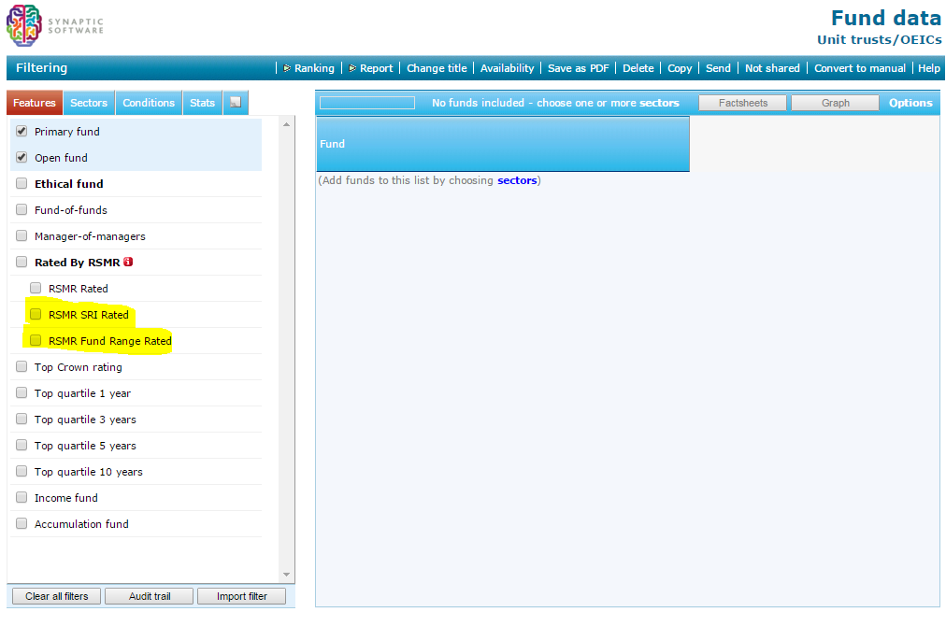

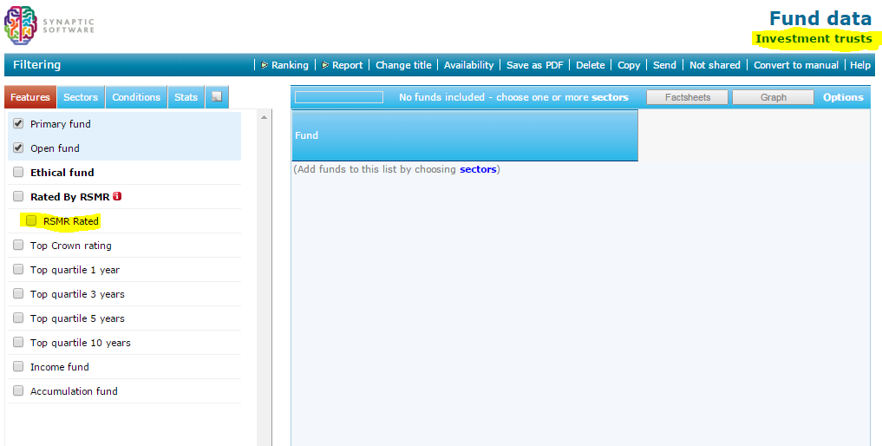

Along with having new features the new stamps and supplementary data have been included on all appropriate fund factsheets.

**Ethical Features**

We have updated our ethical features based on feedback from industry expert Julia Dreblow. The Ethical features can be found in the usual location within P&F.

